Personal Medication
What is personal importation?
A personal importation is a product not for further sale or distribution into U.S. commerce. These products may be carried in baggage or shipped by courier or international mail.

U.S. Citizens
In most circumstances, it is illegal for individuals to import drugs or devices into the U.S. for personal use because these products purchased from other countries often have not been approved by FDA for use and sale in the U.S. For example, a drug approved for use in another country but not approved by FDA would be considered an unapproved drug in the U.S. and, therefore, illegal to import.
FDA cannot ensure the safety and effectiveness of medicine purchased over the Internet from foreign sources, storefront businesses that offer to buy foreign medicine for you, or during trips outside the U.S. For these reasons, FDA recommends only obtaining medicines from legal sources in the U.S.

Foreign Nationals
A foreign national is any person who is not a citizen or permanent resident of the U.S

If you are traveling to the U.S. from a foreign country for vacation, attending university, travel for work, etc… FDA understands that you will need to bring your personal medication while you are in the U.S.

Shipments containing acontrolled substance for personal medicine use are not permitted to be imported.
https://www.deadiversion.usdoj.gov/schedules/orangebook/c_cs_alpha.pdf

FDA will allow foreign nationals to bring or ship a 90-day supply of drug products. If the foreign national is staying longer than 90 days, they may have additional medication sent to them.

Requirements

The following are required for importing medication into the United States:
- Invoice
  - Invoice must be in English
- Importer of Record
  - If the value of the shipment is over $2,500 – Social Security # is required for entry form the importer of record
  - If the value of the shipment is over $5,000 – Power of Attorney is required for entry
- Copy of prescription
- Personal Medication Worksheet (Instructions and worksheet provided)
- Proof of citizenship
Personal Medication Worksheet Instructions

Generic Name or Active Pharmaceutical Ingredient
- Name of your medication
- Active ingredient in your medication
Used to Treat
- Disease or illness this medication is treating for you
Prescription
- Do you have a prescription for this medication?
Daily Dosage
- How many doses you take daily, weekly, etc
  - Example – One 50 mg pill daily
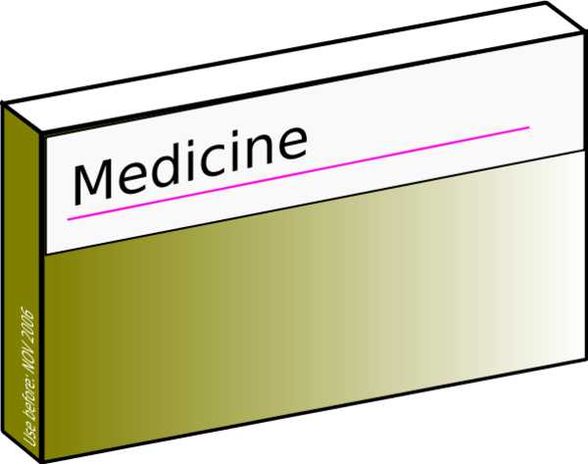

Form
- What form is your medication in?
  - Examples – Pills, capsules, strips, injections, liquids
Units
- How many doses (tablets, pills, injections, etc) are in this shipment?
  - Example – Thirty 50 mg pills
Value
- Value of your medication – this is required for customs
- Specify currency
Manufacturer’s Name and Address
- Full Name and address
  - Street Number
  - Street Name
  - City
  - Country

Generic Name or Active Ingredient | Used to Treat  (Disease or Illness) | Prescription  Y/N | Daily Dosage | Form | Units | Value | Manufacturer’s Name & Address
Thyroid-s  NDT(Natural Dessicated Thyroid) | Hyperthyroidism | Y | 2 to 3 per day | Tablets | 500 x 60mcg | 900 THB | SPS Medical Co., Ltd.  617 Charoen Rat Rd,  Khlong San,  Bangkok, Thailand,  10600

